GAHS/GAMS EBOOKS
Over 150 New Titles Purchased
available through
Follett Library Ebook Services
-----Start Using eBooks and Audiobooks in 4 Easy Steps -----
- Log in to your library’s Destiny Discover.
Go to www.destinydiscover.com
Select your location, and then start typing your school’s name to find it.
Username: firstname.lastname (example: jane.doe) Password: Student ID# (example: 12345)
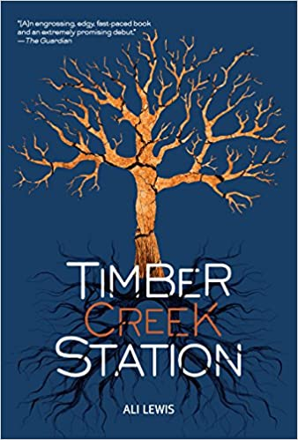
- Find an e-book.
Browse the digital collections featured on your homepage. Or, search, and then use the Format filter to only show the types of books you want to see. Click Open to preview an available title.

- Check it out.
From search results, click Checkout. Or, from an open book, select > Checkout Book.
*Need to take your book offline? No problem! Check out this video: http://bit.ly/ReadOfflineVideo Or, this eBook Help topic: http://bit.ly/ReadOfflineHelp
**What if the book says it’s IN, but there’s no Checkout option? That means your school uses a shared account. Just click Open or Play instead.
***How do I get to my checked-out books? From the top-left corner of any page in Destiny Discover, select > Checkouts (or My Stuff > Checkouts).

- Start reading! They have a Destiny Discover app too!
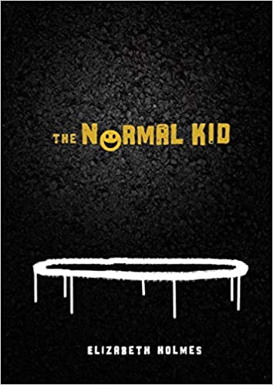
https://www.follettlearning.com/books-materials/learn/digital-content/follett-ebooks/ebook-management/destiny-discover/download
If you have questions, contact your media specialists:
Amanda Bailey - GAHS | amanda.bailey@gc-k12.org
Cheryl Greenlee- GAMS | cheryl.greenlee@gc-k12.org

Thank you to GAHS ASSET, GAMS ROCKS afterschool programs and the Gallia-Vinton ESC for providing our students with e-books!
New Titles Just Purchased
 | Title (Recommended for Middle School) | Title (Recommended for High School)
 | Timber Creek Station | Adventures of Sherlock Holmes
 | Songs of Stones River: A Civil War Novel | Beetle Boy
 | Warriors | Murders in the Rue Morgue
 | Island of Beyond | Normal Kid
 | At the Edge | On the Free
 | At All Costs | Bram Stoker's Dracula
 | Austin | Curtains!: A High School Musical Mystery
 | Circle the Truth | Cask of Amontillado
 | Control Under Fire | Don Quixote
 | Cycling Champion | Curiosities: A Collection of Stories
 | Ropes of the Revolution: The Boston Tea Party | Pit and the Pendulum
 | Last Rider: The Final Days of the Pony Express | Pride and Prejudice
 | Duel of Dragons | Raven
 | Jonathan Swift's Gulliver's Travels | Castle of Lies
 | Hunter's Code | Fall of the House of Usher
 | Santa Fe Jail | Flight of a Starling
 | Size O | Four Secrets
 | Standoff: Remembering the Alamo | Little Women
 | Prank | Marco Polo: Dangers and Visions
 | Oliver Twist | Jules Verne's 20,000 Leagues Under the Sea
 | Time Machine | Paper Butterflies
 | Slammed: Honda Civic | Scar Boys: A Novel
 | Adventures of Tom Sawyer | Scar Girl
 | I, Emma Freke | Sports Shorts
 | Jane Eyre | War of the Worlds
 | Normal Kid | Wonderful Wizard of Oz
 | On the Line | Sin-Eater's Confession
 | Raven Quest | Tell-Tale Heart
 | Truthers | Truthers
 | Wild Hike | Traitor
 | Battle Cry | Wuthering Heights
 | Breathe: A Ghost Story | Case #01: The Haunting of Apartment 101
 | Auma's Long Run | Case #02: The Terror of Black Eagle Tavern
 | Dr. Jekyll & Mr. Hyde | Case #03: The Mayhem on Mohawk Avenue
 | Depth Charge | Case #04: The Bridge of Death
 | You Can Run | Dangerous Magic
 | White Needle | Honor Code
 | Why Did She Have to Die? | Dark Tower Rising
 | When Zombies Invade | What If
 | Thaw | Fallen Star
 | Speed Camp | Lava Crown
 | Signing Day | Skyfall
 | Six-Day Hero | Lost in the River of Grass
 | Ship of Death | Girl Who Owned a City: The Graphic Novel
 | Shipwreck! : A Survival Story | Hound of the Baskervilles
 | Safe Zone | Other Way Around
 | Secrets of the Old Church | Moonlit Road
 | Returning to Shore | Quicksilver
 | On Edge | Returning to Shore
 | Labyrinth | Over a Thousand Hills I Walk with You
 | Hunter's Code | Dig
 | In Trouble | The Downstairs Girl
 | Damage Control | Echo North
 | Cycling Champion | A Heart In a Body in the World
 | 90 Miles to Havana | I, Claudia
 | The Burning Maze | I Was Their American Dream
 | The Crossover | The Kingdom
 | The Dark Prophecy | Lovely War
 | Dragon Captives | The Other Side of the Wall
 | The Evolution of Calpurnia | Pumpkinheads
 | The Graveyard Book | Shakespeare's Hamlet (Manga Edition)
 | The Hidden Oracle | Shakespeare's Julieus Caes (Manga Edition)
 | Island of Fire | Shakespeare's Romeo and Juliet (Manga Edition)
 | Island of Legends | Sorcery of Thorns
 | Island of Silence | Spinning Silver
 | The Tyrant's Tomb | SpyBoy: M.A.N.G.A.
 | The Unwanteds | Stepsister
 | Sir Arthur Conan Doyle's the Adventure of the Six Napoleons
 | Sir Arthur Conan Doyle's the Adventure of the Speckled Band

